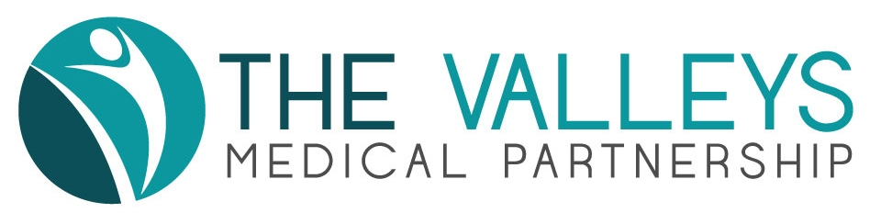
THE VALLEYS MEDICAL PRACTICE PPG

Date: Thursday September 19th 2019

Venue: Gosforth Valley Medical Practice, Dronfield S18 8UE

1. Attendance & Apologies

Present:  Glyn Jones (Chair)  Howard Mills (Minutes)  John Hutchinson  Janice Ashman  Sarah Bond  Ryan Bond  Pat Boyle  Wendy Jones  Jenny Mills  Stuart Tilley (Practice Manager)  Gavin Williamson (Pharmacist) | Apologies:  Helen Lane  Jean Jackson  Mike Kirby  Evelyn Kirby

- Chairman's Welcome and Apologies received

Glyn Jones welcomed attenders, including Janice Ashmore who was attending for the first time. Apologies were noted (see above).

- Minutes of Previous Meetings

The minutes of the previous meeting on April 11th 2019 were accepted as an accurate record, subject to one correction: the title of the meeting at the top of page 1 should read “The Valleys Medical Partnership PPG’

- Matters arising from previous minutes

- Communications Group

Mike Sims provided a contact at Eckington School which Glyn Jones is going to take forward. An approach is also being made to Dronfield School jointly with Oakhill and the Dronfield Practices. The Dronfield Practice will lead on this.

- The Role of the Pharmacist in the Partnership

Gavin Williamson led a session on the role of the pharmacist, how it had developed and what is planned for the future. He outlined a range of key tasks that he is leading including liaison with local Pharmacies, leading tutorials for staff, provision of expert advice to colleagues.
The challenges around the repeat prescriptions issue and ensuring continuity of provision were explained in detail, as well as outlining the advantages both for patients and staff.
Gavin has a key role in influencing the development across the Primary Care Network (PCN) for pharmacy services. Currently, the Valleys is the only Practice within the PCN with an inhouse pharmacy resource, so this will provide further opportunities to improve services for patients.

- Practice Update

Stuart Tilley’s full report is attached. Issues of particular importance are highlighted below:

- Staffing

There are no new appointments to note.

- Primary Care Network

It is hoped that the pharmacist appointed through the PCN funding (see item 4 above) will be in post later in the Autumn. The PCN funding for social prescribing has led to the Practices within the PCN agreeing a partnership with Derbyshire Voluntary Action (DVA) for the management and supervision of the worker appointed to provide the service to patients across the PCN. DVA is also providing this service through the other Practices in Dronfield (which are of course in a separate PCN).

7. Any Other Business

Joined Up Care Derbyshire is looking to recruit members for its Citizens’ Panel. Anyone interested can find out more via the website (joinedupcarederbyshire.co.uk) or by contacting Glyn Jones (not before late October). Membership of the Citizens’ Panel is open to any patient and not restricted to PPG members.

8. Dates of Next PPG

November 19th 2019 at 1830 (Moss Valley) - please note change of date from the original date of November 21st.

hm210919

